**Reflection & Refraction**

Todd Blacklaw

Heriot-Watt University Physics Department

E-mail: [tb2007@hw.ac.uk](mailto:tb2007@hw.ac.uk)

Abstract

This study aims to experimentally ascertain the refractive index of a dielectric material employing Snell's Law, Brewster's Angle, and the Fresnel Coefficients, subsequently evaluating the accuracy and precision of each method. The obtained results yielded a refractive index of 1.462 ± 0.05 for the material. Notably, the calculation of Fresnel coefficients emerged as the most accurate and precise method, offering a direct quantification of light reflectance and transmittance. These findings underscore the efficacy of employing Fresnel coefficients in refractive index determination, thereby providing valuable insights for optical characterization and material analysis.

1. Introduction

The aim of this report is to document and analyze each experimental method to obtain the refractive index of an unknown dielectric material and then determine which method has the highest accuracy and precision relative to the theoretical value of refractive index.

This is interesting to investigate as it allows for the calibration and quality control of optical experiments used in telecommunications and materials science due to experimentally verifying the refractive index of an unknown material and ensuring its accuracy and precision are known and as minimised as possible.

This experiment gives an introduction to basic optical systems as well as using optical calculations such as Snell’s Law and Brewster’s Angle. It also gives practice for the experimental framework for future optical systems where the refractive index must be verified with as high precision and accuracy as possible.

2. Background Theory

2.1 Refractive Index

Refractive index is a material property that describes how the material affects the speed of light travelling through it [1]. These interactions, governed by the material's complex permittivity, lead to a reduction in the speed of light as it propagates through the medium compared to its velocity in vacuum. The refractive index, denoted by n, quantifies this reduction, and is defined as the ratio of the speed of light in vacuum c to the phase velocity of light in the material vp, i.e., n=vp​c​.

Figure 1. A ray of light traveling from a vacuum to a medium with a higher refractive index and being refracted inside the medium [2]

The refractive index is intimately linked to the material's electronic and atomic structure, with variations in density, electronic configuration, and polarizability influencing its value. Moreover, the refractive index is wavelength-dependent due to dispersion effects, where different wavelengths of light experience varying degrees of bending as they pass through the material.

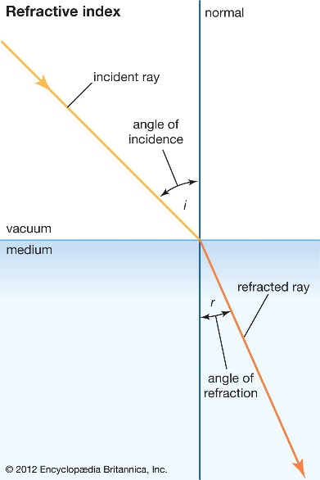In addition to its foundational role in optics, the refractive index serves as a fundamental parameter in diverse fields such as quantum optics, metamaterials, and plasmonics. Understanding and manipulating the refractive index enables control over light-matter interactions at the nanoscale, facilitating innovations in optical computing, sensing, and imaging technologies.

2.2 Snell’s Law

Snell's law, a cornerstone of geometric optics, elucidates the behaviour of light at the interface between two media with different refractive indices through the framework of Fermat's principle. By considering the paths of light rays as extremal paths of the optical path length, Snell's law rigorously connects the angles of incidence and refraction to the refractive indices of the media involved. Mathematically, Snell's law is formulated as n1​sin(θ1​) = n2​sin(θ2​) (1), where n1​ and n2 are the refractive indices of the incident and transmitting media respectively, and θ1 and θ2​ are the angles of incidence and refraction with respect to the interface normal.

Snell's law extends beyond linear optics, finding applications in nonlinear optics, where the refractive index becomes intensity-dependent due to optical nonlinearities. This nonlinear regime gives rise to phenomena such as self-focusing, soliton propagation, and harmonic generation, offering avenues for exploring novel optical functionalities and devices.

Snell's law serves as a fundamental principle in fields beyond traditional optics, including acoustics, fluid dynamics, and seismology, where analogous laws govern the propagation of waves through different media.

Figure 2. Refraction of light at the interface of two mediums with different refractive indices with n2 > n1 [3]

2.3 Brewsters Angle

Brewster's angle arises from the interaction between light and matter at dielectric boundaries. It occurs when the tangential component of the incident light's electric field aligns with the plane of incidence, causing constructive interference in the transmitted wave and destructive interference in the reflected wave, specifically for s-polarized light. Mathematically, Brewster's angle (θB) is given by (2), where n1 and n2 are the refractive indices of the incident and transmitting media, respectively.

This angle has practical applications in ellipsometry, where it helps analyse thin film properties like thickness and refractive index. In laser optics, Brewster's angle is crucial for designing polarization-preserving optical components and reducing unwanted reflections in high-power laser systems.

Brewster's angle is relevant beyond traditional optics, extending to phenomena like acoustic waves in solids and surface plasmon polaritons at metal-dielectric interfaces, demonstrating its broad significance across various disciplines.

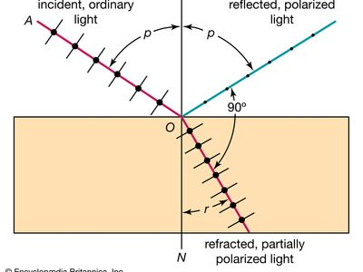

Figure 3. Unpolarized laser light hits a medium at the Brewster’s angle and has the polarised light reflected while the other polarised light is refracted. In this experiment, since the laser light will be polarized all the light should be reflected. [4]

2.4 Fresnel equation

The study of light interacting with boundaries between different media is fundamental in optics and materials science. When light encounters an interface between two materials with different refractive indices, part of the incident light is reflected and part is transmitted. The behaviour of light at these interfaces is described by Fresnel equations, named after the French physicist Augustin-Jean Fresnel, who derived them in the early 19th century.

When light travels from one medium to another, its behaviour is governed by the laws of electromagnetism, particularly Maxwell's equations. At the interface between two media, the incident light can undergo reflection and transmission. The ratio of reflected to incident light intensity is quantified by the reflection coefficient, and the ratio of transmitted to incident light intensity is quantified by the transmission coefficient.

The Fresnel equations provide a mathematical description of the reflection and transmission coefficients for light incident on an interface between two media with different refractive indices. These coefficients are influenced by the polarization state of the incident light and the angle of incidence.

For unpolarized light, the Fresnel equations give the average reflection and transmission coefficients over all possible polarization states. For light incident at an angle θi from the normal to the interface, the Fresnel equations are given by:

(3)

(4)

Where and are the reflectance for horizontally and vertically polarisation respectively and and are the angles of incidence and transmittance respectively.

In experimental studies, particularly in optics and material science, the Fresnel equations play a crucial role. They are used to predict and analyse the behaviour of light at material interfaces, aiding in the design of optical components such as lenses, mirrors, and coatings. Additionally, they are employed in techniques such as ellipsometry, which utilizes polarized light to characterize the optical properties of thin films and surfaces.

In this lab experiment, the Fresnel coefficients will be utilized to understand the behaviour of light at the interface between the unknown material and its surrounding medium. By measuring the reflection and transmission of light at various angles of incidence, the refractive index of the unknown material can be determined using the Fresnel equations and Snell's law.

Figure 4. Diagram of all the variables used in the Fresnel Coefficients. [5]

3. Experimental Method

3.1 Laser setup and calibration

For this experiment, the apparatus consists of the following an optical rail bench, a 633nm semiconductor laser and its mount, a polariser with a graduated rotational mount, a rotating table consisting of a circular table with angle grauations and a mounting plate, a rotating indicator arm for measuring beam angles, a quartz half-cylinder and an optical detector mounted on a rotating arm for measuring the transmitted and reflected power.

Once the laser has been set up as seen in figures 5 and 6 the laser and polarizer must be calibrated to show a maximum power output in the P polarisation plane. Turn on the laser and the optical detector then align the laser through the polariser and incident to the optical detector then set the polariser to 0°. Rotate the laser diode in its mount until the maximum power output is read on the detector then tighten all the fittings to ensure nothing rotates during the experiment. This will allow for a more accurate reading of the polarised power in the S and P planes as there should be a clear minimum in the S plane when the polarizer is rotated 90°.

Figure 5. Picture showing all apparatus labelled and used during the experiment. [6]

Figure 6. Schematic showing the laser being aligned with the polariser, indicator arm, quartz half-cylinder and the optical detector [6]

3.2 Snell’s Law

To use Snell’s Law to verify the refractive index of the material the polariser and optical detector will need to be removed from the rail and the laser incident to the surface of the half-cylinder. Then rotate the half-cylinder to have the flat side incident to the laser, and by increasing the angle of incidence by 5° increments from 0° to 60° measure the angle of refraction using the indicator arm.

Then, using Snell’s Law in equation (1) plot ​sin(θ1​) against ​sin(θ2​) as n1​ = 1 as it’s the refractive index of air. The equation is in the form y=mx + c so taking the gradient will give the refractive index of the half-cylinder (n2​). Then rotate the half-cylinder so that the curved end is incident to the laser take the same measurements from 0° to 55° and note the critical angle.

3.3 Brewster’s angle and Fresnel coefficients

For finding the Brewster’s angle and using the Fresnel coefficients the polariser and the optical detector will need to be fitted back onto the rail and aligned with the laser again. Once it is set up like in Figure 6 align the laser and the quartz half-cylinder’s flat side so that they are incident to each other then take a maximum reading then adjust the angle of incidence to 10° and take another reading. This will allow for any corrections to be made to the power output value during the experiment. Once that is done take reading of the power output of the reflected beam from 10° to 90° at 5° intervals in both the P and S polarisation planes by rotating the polariser. Note if the laser was horizontally or S polarised before it passed the filter the Brewsters angle can only be observed in the vertical or P plane and this is the same if the laser was vertically polarised when the initial set up was done.

Once the reading of the reflectance beam’s power output has been taken adjust the quartz half-cylinder to have the curved side incident to the laser and take the same readings with the polariser being in the S and P plane.

Now using equation (3) and equation (4) calculate the reflectance of the half-cylinder and plot reflectance vs angle of incidence and note the differences between the low – high plot and the high – low plot.

4. Results, Analysis and Discussion

4.1 Snell’s Law

From the measurement of the critical angle during this experiment an estimation of the refractive index can be made. Using Snell’s Law from equation (1) as at the critical angle θ2 = 90° since the light is refracted along the surface of the material this becomes where is the critical angle solving for we get as in air which gives an answer of 1.47 ± 0.08 (A.1) which agrees with the theoretical refractive index of quartz.

Using this estimated value of the refractive index a plot of sin θi vs sin θr can be made to compare the experimental data and the theoretical plot. From this plot a line of best fit can be fitted to the data points and the gradient or and its respective error can be calculated. This was calculated in MATLAB using the polyfit and polyval functions (A.2).

Figure 7. MATLAB plot showing Snell's Law experimental data superimposed on a theoretical fit. And the calculated refractive index along with its error

From figure 7 we can see that the experimental data points and the theoretical fit are similar and show that the gradient calculated from the experimental data was given to be 1.46 ± 0.1. This error is quite large due to the measurements of both the angle of incidence and the angle of refraction being done on an analogue graduated scale and that the iterations of data points taken were quite large. If this had been reduced from 5 to 1 then the error would be smaller but still significant.

4.2 Brewsters Angle

The Brewsters angle was measured during the Fresnel Coefficient method of this experiment. It could only be observed in the P polarisation plane as the laser was calibrated to be aligned with the S plane. As seen in figures 8 and 9 the Brewsters angle was directly observed during the experiment and noted in the data collection done in Excel (A.3).

The Brewsters angle can also be calculated using equation (2) and this results in a refractive index of 1.43 ± 0.15 (A.4) which agrees with the theoretical value of refractive index.

This error is large due to the large iterations of angles observed for the experiment. If smaller steps could have been taken this would result in a smaller error and more precise results.

Figure 8. MATLAB plot showing the low - high P and S polarisations using the reflectance coefficient and angle of incidence. The calculated refractive index and its error are shown in the legend.

Figure 9. MATLAB plot showing the low - high P and S polarisations using the reflectance coefficient and angle of incidence. The calculated refractive index and its error are shown in the legend.

4.3 Fresnel Coefficient

Looking at figures 7 and 9 the S and P polarisations for both low – high and high – low indexes show that when the polariser was rotated to be in the P plane the reflectance coefficient decreased towards 0 at around 55° showing the Brewsters angle in both figures. The calculations for the refractive index were done in MATLAB and documented in the legend. These calculations were done using the PolFit command taking the 1st index as the refractive index and the 2nd index as the calculated error (A.2)

The data shown in both plots agree with the theoretical value for the refractive index as for low – high refractive index, it was calculated to be 1.46 ± 0.17 in the P plane and 1.69 ± 0.021 in the S plane. For high – low the P plane’s refractive index was calculated to be 1.39 ± 0.3 and 1.37 ± 0.043 in the S plane.

The errors in the S plane were significantly lower than in the P plane and were also lower than the errors for Snell’s law and Brewster’s angle calculations. This is due to a few issues including bad polarising filters that would randomly not polarise some of the laser and thus effect the optical detector’s reading’s, the optical detector’s scale would show an error as the power of the laser was too high and lastly imperfections in the quartz half-cylinder as there were many scratches and a large chip in one of the sides.

5. Discussion

5.1 Snell’s Law

The refractive index calculated using Snell’s Law was 1.462 ± 0.1. This value is very close to the real value of refractive index of quartz, which is 1.458, this is due to the experiment not requiring the polariser or optical detector which led to better results. The error however is large due to the reading errors in both the angle of incidence and refraction as it was given to be ± 0.05° which was used in the error propagation calculations.

5.2 Brewster’s angle

The Brewsters angle was experimentally established during the Fresnel Coefficient data collection by observing the reflection power output drop to near 0° and become delocalized. Using the Brewster’s angle equation the true Brewsters Angle for the quartz half-cylinder is around 55.55°. This angle could have been more accurately observed if the iteration of the incident angle was lower from 5 to 1.

5.3 Fresnel Coefficient

The refractive index calculated for each plane of polarisation and each material index was 1.46 ± 0.17 for P and 1.69 ± 0.021 for S, with the quartz half-cylinder in the low – high index. Then it was calculated as 1.39 ±0.3 for P and 1.37 ± 0.043 for S in the high – low index. This method should have resulted in a lower error than the other methods due to its direct mathematical relation to the refractive index without relying on experimental measurements. But as clearly seen in the P polarisation planes the error is significantly higher than the S planes. This is due to the imperfections in both the polariser and the quartz which would affect the P plane more than the S plane as the laser was aligned with the S plane so when the polariser is rotated it isn’t polarising all the light from the laser.

6. Conclusion

This experiment has shown that the refractive index of an unknown material can be calculated using Snell’s law, establishing Brewster’s angle, and using the Fresnel coefficients. In each method the refractive index was calculated successfully and agreed with the theoretical value of 1.458. However, for Snell’s Law and Brewster’s angle the error in the calculation was quite high which would result in a poor verification method for finding the refractive index of an unknown material. The Fresnel coefficients gave the smallest error when the laser was aligned in the same polarisation plane which makes sense due to the other two methods needing the angles measured using the analogue graduated scale on the disk.

References

1. IOP Glossary, <https://spark.iop.org/refractive-index>, Institute of Physics, accessed 29/03/2024
2. Britannica, The Editors of Encyclopaedia. "refractive index". *Encyclopedia Britannica*, 1 Mar. 2024, <https://www.britannica.com/science/refractive-index> . Accessed 4 April 2024.
3. Snells Law, Wikipedia, <https://en.wikipedia.org/wiki/Snell%27s_law#cite_note-1> , accessed 1/04/2024
4. Britannica, The Editors of Encyclopaedia. "Brewster’s law". Encyclopedia Britannica, 7 Dec. 2023, <https://www.britannica.com/science/Brewsters-law> . Accessed 5 April 2024.
5. Wikipedia contributors, 'Fresnel equations', *Wikipedia, The Free Encyclopedia,* 28 February 2024, 18:50 UTC, <<https://en.wikipedia.org/w/index.php?title=Fresnel_equations&oldid=1210866386>> [accessed 5 April 2024]
6. OproSci, “Reflection & Refraction Educator Kit Student Manual”, Prof Walter Johnstone, Dept. Electronic and Electrical Engineering University of Strathclyde, Glasgow

Appendix

A.1

A.2

clc;

clear;

% Snell's Law data

Sinr = [0, 0.06104854, 0.121869343, 0.190808995, 0.241921896, 0.292371705, 0.342020143, 0.406736643, 0.4539905, 0.48480962, 0.515038075, 0.559192903, 0.601815023];

Sini = [0, 0.087155743, 0.173648178, 0.258819045, 0.342020143, 0.422618262, 0.5, 0.573576436, 0.64278761, 0.707106781, 0.766044443, 0.819152044, 0.866025404];

% Error in Sini and Sinr

error_Sini = 0.05;

error_Sinr = 0.05;

% Define incident angles from 0 to 60 degrees

incident_angles_deg = 0:60;

incident_angles_rad = deg2rad(incident_angles_deg);

% Calculate corresponding refracted angles using Snell's Law

n1 = 1; % Refractive index of medium 1

n2 = 1.458; % Refractive index of medium 2

refracted_angles_rad = asin(n1 / n2 * sin(incident_angles_rad));

% Plot the data points with error bars

figure(1);

errorbar(Sinr, Sini, error_Sini*ones(size(Sini)), error_Sini*ones(size(Sini)), error_Sinr*ones(size(Sinr)), error_Sinr*ones(size(Sinr)), 'o');

hold on;

% Fit a line

p = polyfit(Sinr, Sini, 1); % Flipped Sinr and Sini

x_fit = linspace(min(Sinr), max(Sinr), 100);

y_fit = polyval(p, x_fit);

plot(x_fit, y_fit, 'r');

% Calculate the gradient

gradient = p(1);

% Perform error propagation

% Error in gradient (slope)

error_gradient = sqrt((error_Sinr / range(Sinr))^2 + (error_Sini / range(Sini))^2);

% Display the gradient and its error

disp(['Gradient of the best-fit line: ', num2str(gradient)]);

disp(['Error in gradient: ', num2str(error_gradient)]);

% Plot theoretical Snell's Law

plot( sin(refracted_angles_rad),sin(incident_angles_rad), 'g--');

xlabel('Sinθr');

ylabel('Sinθi');

title('Snells law experimental and theoretical plot');

legend('Data Points with Error Bars', 'Best-fit Line', 'Theoretical Snell''s Law (n1=1, n2=1.458)');

grid on

xlim([0 0.7])

ylim([0 1])

legend("Position", [0.14856,0.75794,0.51823,0.12788])

hold off

% Freznel Coefficients

AngleOfIncidence = [10,15,20,25,30,35,40,45,50,55,60,65,70,75,80,85,90];

SPolarisationLowHigh = [0.048,0.051,0.054,0.064,0.068,0.074,0.081,0.097,0.116,0.163,0.169,0.207,0.314,0.429,0.569,0.753,0.995];

PPolarisationLowHigh = [0.041,0.049,0.026,0.023,0.019,0.015,0.013,0.009,0.006,0.001,0.028,0.045,0.053,0.104,0.262,0.541,0.993];

figure(2);

hold on

% Plot the measured points using errorbar()

errorbar(AngleOfIncidence, PPolarisationLowHigh, 0.05 * ones(size(PPolarisationLowHigh)), 'b+');

errorbar(AngleOfIncidence, SPolarisationLowHigh, 0.05 * ones(size(PPolarisationLowHigh)), 'ro');

% Add vertical line at Brewster's angle

line([55, 55], ylim, 'Color', 'k', 'LineStyle', '--');

xlabel('Angle of incidence (degrees)');

ylabel('Reflection coefficient');

legend('P polarisation data Low - High', 'S polarisation data Low - High', 'Brewster''s Angle');

axis normal

grid on

box on

% Generate the theory data

AngleOfIncidenceDegrees = 0:1:90;

n = 1.458; % Refractive index

Rs = abs((cosd(AngleOfIncidenceDegrees) - n*sqrt(1 - (1/n)*sind(AngleOfIncidenceDegrees).^2)) ./ (cosd(AngleOfIncidenceDegrees) + n*sqrt(1 - (1/n)*sind(AngleOfIncidenceDegrees).^2))).^2;

Rp = abs((-n*cosd(AngleOfIncidenceDegrees) + sqrt(1 - (1/n)*sind(AngleOfIncidenceDegrees).^2)) ./ (n*cosd(AngleOfIncidenceDegrees) + sqrt(1 - (1/n)*sind(AngleOfIncidenceDegrees).^2))).^2;

% Plot the theory data

plot(AngleOfIncidenceDegrees, Rp, 'blue');

plot(AngleOfIncidenceDegrees, Rs, 'red');

% Find the best fit

SPolFit = fitnlm(AngleOfIncidence', SPolarisationLowHigh', @(n, theta) ReflectionS(n, theta), [1.5]);

PPolFit = fitnlm(AngleOfIncidence', PPolarisationLowHigh', @(n, theta) ReflectionP(n, theta), [1.5]);

% Generate the fit data

SPol_n = SPolFit.Coefficients{1, 1};

PPol_n = PPolFit.Coefficients{1, 1};

SPol_error = SPolFit.Coefficients{1, 2};

PPol_error = PPolFit.Coefficients{1, 2};

RsFit = abs((cosd(AngleOfIncidenceDegrees) - SPol_n*sqrt(1 - (1/SPol_n)*sind(AngleOfIncidenceDegrees).^2)) ./ (cosd(AngleOfIncidenceDegrees) + SPol_n*sqrt(1 - (1/SPol_n)*sind(AngleOfIncidenceDegrees).^2))).^2;

RpFit = abs((-SPol_n*cosd(AngleOfIncidenceDegrees) + sqrt(1 - (1/SPol_n)*sind(AngleOfIncidenceDegrees).^2)) ./ (SPol_n*cosd(AngleOfIncidenceDegrees) + sqrt(1 - (1/SPol_n)*sind(AngleOfIncidenceDegrees).^2))).^2;

% Plot the best fit lines

plot(AngleOfIncidenceDegrees, RpFit, 'blue--');

plot(AngleOfIncidenceDegrees, RsFit, 'red--');

xlabel('Angle of incidence (degrees)');

ylabel('Reflection coefficient');

axis([0, 90, -0.1, 1]);

% Add legend and title

legend('P polarisation data Low - High', 'S polarisation data Low - High', ...

'Brewster''s Angle', 'P polarisation theory', 'S polarisation theory', ...

['P polarisation best fit, n = ', num2str(PPol_n), ' \pm ', num2str(PPol_error)], ...

['S polarisation best fit, n = ', num2str(SPol_n), ' \pm ', num2str(SPol_error)]);

title('Fresnel Coefficients for S and P Polarised light');

legend("Position", [0.1633,0.62619,0.55973,0.26992])

hold off

legend(["P polarisation data Low - High","S polarisation data Low - High","Brewster""s Angle","P polarisation theory","S polarisation theory","P polarisation best fit, n = 1.4565 \pm 0.173","S polarisation best fit, n = 1.6917 \pm 0.021"])

% High to Low index data

AngleOfIncidenceHL = [10,15,20,25,30,35,40,45,50,55,60,65,70,75,80,85,90];

SPolarisationHL = [0.026,0.042,0.048,0.051,0.057,0.063,0.067,0.084,0.103,0.108,0.114,0.117,0.123,0.238,0.378,0.562,0.804];

PPolarisationHL = [0.023,0.019,0.016,0.013,0.012,0.009,0.006,0.005,0.001,0.017,0.019,0.038,0.046,0.084,0.252,0.433,0.703];

% Clear the current figure

clf;

figure(3);

hold on

% Plot the measured points using errorbar()

errorbar(AngleOfIncidenceHL, PPolarisationHL, 0.05 * ones(size(PPolarisationHL)), 'b+');

errorbar(AngleOfIncidenceHL, SPolarisationHL, 0.05 * ones(size(PPolarisationHL)), 'ro');

% Add vertical line at Brewster's angle

line([55, 55], ylim, 'Color', 'k', 'LineStyle', '--');

xlabel('Angle of incidence (degrees)');

ylabel('Reflection coefficient');

legend('P polarisation data High - Low', 'S polarisation data High - Low', 'Brewster''s Angle');

axis normal

grid on

box on

% Generate the theory data

AngleOfIncidenceDegrees = 0:1:90;

n = 1.458; % Refractive index

Rs = abs((cosd(AngleOfIncidenceDegrees) - n*sqrt(1 - (1/n)*sind(AngleOfIncidenceDegrees).^2)) ./ (cosd(AngleOfIncidenceDegrees) + n*sqrt(1 - (1/n)*sind(AngleOfIncidenceDegrees).^2))).^2;

Rp = abs((-n*cosd(AngleOfIncidenceDegrees) + sqrt(1 - (1/n)*sind(AngleOfIncidenceDegrees).^2)) ./ (n*cosd(AngleOfIncidenceDegrees) + sqrt(1 - (1/n)*sind(AngleOfIncidenceDegrees).^2))).^2;

% Plot the theory data

plot(AngleOfIncidenceDegrees, Rp, 'blue');

plot(AngleOfIncidenceDegrees, Rs, 'red');

% Find the best fit

SPolFitHL = fitnlm(AngleOfIncidenceHL', SPolarisationHL', @(n, theta) ReflectionS(n, theta), [1.5]);

PPolFitHL = fitnlm(AngleOfIncidenceHL', PPolarisationHL', @(n, theta) ReflectionP(n, theta), [1.5]);

% Generate the fit data

SPol_nHL = SPolFitHL.Coefficients{1, 1};

PPol_nHL = PPolFitHL.Coefficients{1, 1};

SPol_errorHL = SPolFitHL.Coefficients{1, 2};

PPol_errorHL = PPolFitHL.Coefficients{1, 2};

RsFit = abs((cosd(AngleOfIncidenceDegrees) - SPol_nHL*sqrt(1 - (1/SPol_nHL)*sind(AngleOfIncidenceDegrees).^2)) ./ (cosd(AngleOfIncidenceDegrees) + SPol_nHL*sqrt(1 - (1/SPol_nHL)*sind(AngleOfIncidenceDegrees).^2))).^2;

RpFit = abs((-SPol_nHL*cosd(AngleOfIncidenceDegrees) + sqrt(1 - (1/SPol_nHL)*sind(AngleOfIncidenceDegrees).^2)) ./ (SPol_nHL*cosd(AngleOfIncidenceDegrees) + sqrt(1 - (1/SPol_nHL)*sind(AngleOfIncidenceDegrees).^2))).^2;

% Plot the best fit lines

plot(AngleOfIncidenceDegrees, RpFit, 'blue--');

plot(AngleOfIncidenceDegrees, RsFit, 'red--');

xlabel('Angle of incidence (degrees)');

ylabel('Reflection coefficient');

axis([0, 90, -0.1, 1]);

% Add legend and title

legend('P polarisation data High - Low', 'S polarisation data High - Low', ...

'Brewster''s Angle', 'P polarisation theory', 'S polarisation theory', ...

['P polarisation best fit, n = ', num2str(PPol_nHL), ' \pm ', num2str(PPol_errorHL)], ...

['S polarisation best fit, n = ', num2str(SPol_nHL), ' \pm ', num2str(SPol_errorHL)]);

title('Fresnel Coefficients for S and P Polarised light');

hold off

legend(["P polarisation data High - Low","S polarisation data High - Low","Brewster""s Angle","P polarisation theory","S polarisation theory","P polarisation best fit, n = 1.3941 \pm 0.297","S polarisation best fit, n = 1.3687 \pm 0.043"])

legend("Position", [0.15896,0.61608,0.57276,0.28212])

% Define the functions for the Fresnel coefficients

function [ReflectionDataS] = ReflectionS(n2, theta)

ReflectionDataS = abs((cosd(theta) - n2*sqrt(1 - (1/n2)*sind(theta).^2)) ./ (cosd(theta) + n2*sqrt(1 - (1/n2)*sind(theta).^2))).^2;

end

function [ReflectionDataP] = ReflectionP(n2, theta)

ReflectionDataP = abs((-n2*cosd(theta) + sqrt(1 - (1/n2)*sind(theta).^2)) ./ (n2*cosd(theta) + sqrt(1 - (1/n2)*sind(theta).^2))).^2;

end

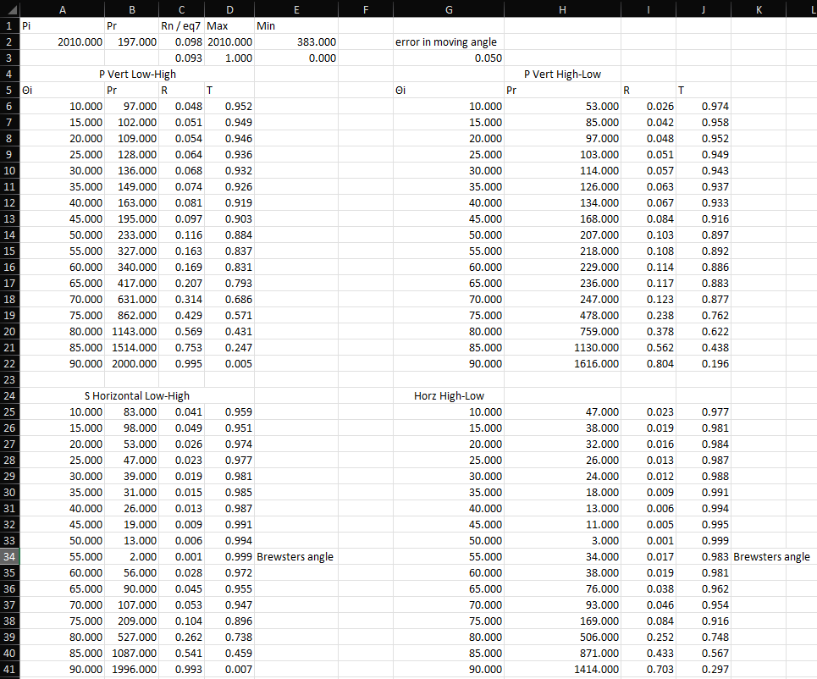A.3

A.4